GUI Objects:
Here we investigate the attributes of objects in Graphical User Interfaces

LibreOffice Impress:
Go to Tools / Development Tools to see properties and methods.
Properties:
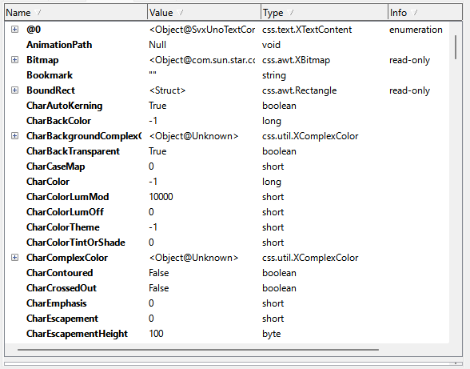

Methods:
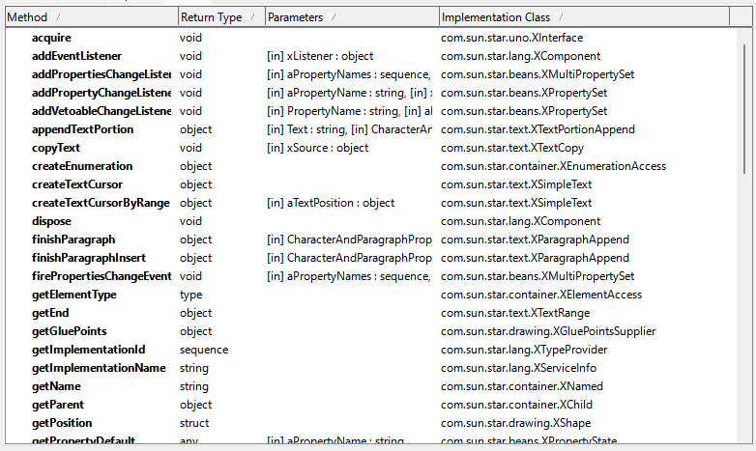
A LibreOffice Express presentation is basically a GUI program, where each slide is basically a “form” in Visual Basic.
Each object has hundreds of properties, which themselves can be objects, and roughly a hundred methods.
I don’t intend to implement all of these properties and methods. Instead adding only what is needed. There is simply too much to keep track of.

Visual Basic 6.0 1998

The following are for the CommandButton in VB6
Properties:
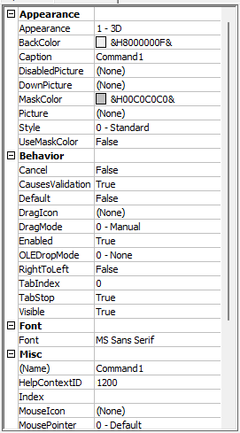
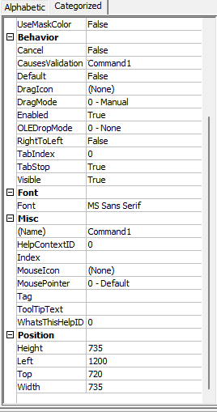

Methods: (double click object to generate code stubs to give methods to objects)
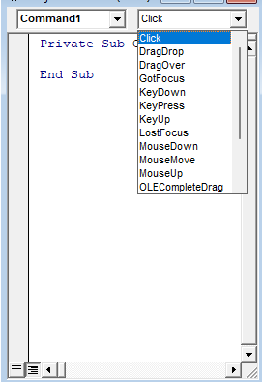
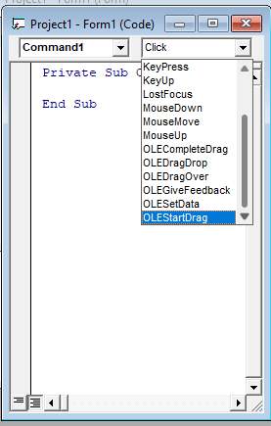

Each object has a sensible number of properties and methods. There are different classes such as CommandButtons and TextBoxes, with overlapping sets of properties and methods.
In Spaghetti Graveyard there will be one gui object class, with type specific data stored in a union of structs within the main struct. We have been avoiding using the memory allocator and instead putting objects in pools. Since the gui objects are created at the start of the game and not destroyed, we can get away with using the memory allocator without much slow-down.
Methods will be stored as integer addresses within vtables. Each object should contain a struct, itself containing a list of these integer addresses.

